Meta Description:
Learn how Lucho's expert wardrobe stylists can transform your confidence, save time, and elevate your personal brand through personalized fashion choices.

How Expert Wardrobe Styling Specialists Can Change Your Life?

Just picture getting out of bed and looking forward to opening your closet door full of stylish clothes that represent your style. You can be assured that this collection will give you that confidence, and match your daily hustle and bustle. This is the beauty that the professional wardrobe stylists do, and at Lucho, we have embraced the ability of these specialists to transform your lives. So, let’s understand how these style gurus can take the dullness of a routine morning and turn it into a qualified moment to embrace.

Upgrade Your Style:
The primary role that wardrobe styling specialists can play in your life is the ability to herald your unique fashion identity. We have all happened to step in front of a closet full of clothes and wondered what we want to wear. In the end, we find ourselves with a combination that we do not like. It’s a common struggle. The expert stylists make it easier for you to collect pieces that are not only appropriate for you but also meaningful.

A wardrobe stylist does not just plan, design, or select your clothes without first understanding your likes, needs, and expectations. Such specialists always inquire about your favorite colors, patterns, and fabrics, and always listen to your requirements. In this way, they contribute to finding out which style is the most suitable for you or, in other words, help to find your individuality. This is the best option for those who prefer the timeless designs of the traditional furnishings, the colorful and sturdy apparel of the streets, and the sleek and sober clothes of the fashion magazines.

Boost Your Confidence:
Our sense of identity strongly depends on fashion because it helps us appear as we want to be seen. So, choosing clothes that agree with your taste and follow fashion styles can make you feel better about yourself. Picture entering a meeting, a date, or even an ordinary dinner with the right combination of clothes. This will give you the confidence of a movie star. Fashion designers, specifically wardrobe stylists, know exactly what garments make you look and feel like a superstar.
Confidence is a great factor that can be described as the key that unlocks the door. You know very well that people are always attracted to confident personalities, and this is where your style comes in. A right stylist will provide you with a dressing that prepares you to confront and conquer the world on any occasion.

Save Time and Money:
Unfortunately, time is limited, and morning time is particularly short, and many activities can get in the way. Consequently, styling becomes easy when you have a well-selected wardrobe. Our wardrobe stylists guide you through the space and assist in the removal of the items that are not used frequently and the acquisition of the garments that will last for a long time.

Of greater significance, a fashion expert can help you save a lot of your money over a specific period. Moreover, stylists are equally useful in advising on how to layer one’s fashion items, which ensures that you make the most out of your clothes without having to purchase new clothes often.

Uplift Your Brand:
In today’s society, everyone is a brand, and personal branding is a major part of every society. As a businessperson, an aspiring businessman, or anybody who simply wants to be socially respected, the clothes you wear have a very significant impact on your appearance. A wardrobe stylist always helps you to build a perfect wardrobe collection that shows your desired presence in all situations.

Through the selection of appropriate dressing, professionals display their professional skills to perform their tasks at work. The trained attire demonstrates professional confidence to match a business person's spirited character. A wardrobe stylist uses your preferences and style goals to create clothing choices that align with your needs and desired image.

Enhance Your Well-being:
Human beings have many life choices that help them reduce their stress and create better feelings. Scientific studies show that your choice of clothes directly influences both your mental state and your physical condition. People's personal feelings and social energy levels are directly affected by what clothes they wear. When you wear pleasant garments, you feel better.
As a wardrobe professional, Lucho's experts design outfits that mix elegance with user-friendly features. By selecting the right materials and designs, our experts bring calmness to all parts of your day.

Prepare for Special Occasions:
Almost everyone experiences several meaningful events like weddings, marriage, parties, celebrations, achievements, and time off work. That is why wardrobe stylists perform excellently in providing you with these occasions. They assist in choosing the right attire to wear during the event. Whether you want to grace the wedding or any other event in a delightful dress and suit, a right stylist will make sure that your outfit will turn heads.

Usually, people are busy and do not pay much attention to clothes design, but having a stylist next to you will make each moment special. A right wardrobe stylist ensures that during the special moments, your outfit will also be special, so you do not have to worry about this at all.

Embrace Change:
Individuals change with age, and the clothes they wear have to be adjusted with that change. Change is ever constant, and that is why a wardrobe stylist becomes a very handy friend in managing the change. Regardless of whether you are changing your career, leaving school, entering the workforce, or going through any other life change, a stylist is someone who offers advice and fosters encouragement.

They assist you in releasing things that may not be suitable for your life now and adopt changes that are trendy and stylish for your current existence. And the best thing here is that this creates the ability to develop a wardrobe that remains fresh and suitable for you at various stages of your life.

Sustainable Fashion Choices:
Modern wardrobe professionals always advise people on fashion style, with more focus on protecting our environment when making their recommendations. They help you build wardrobes from established brands that use eco-friendly materials.

By limiting the number of outfits worn and choosing the real quality instead of numerous trendy but low-quality clothes, stylists promote the sustainability of clothes and thoughtful consumption. Besides, it is friendly to the environment to reduce the constant cycle of purchasing new clothing only to discard the old ones after just a few uses.

Final Thoughts:
A wardrobe styling professional can be your best friend and a savior who can transform your life. Starting with revealing your personality and confidence, saving money and time, improving your style and image, physical and mental health, and everything that comes with it, a right stylist knows everything about your life.

Our basis for business at Lucho is in providing clothes that make people feel confident, comfortable, and fashionable in their daily lives. To this effect, the wardrobe styling specialists here strive to ensure that your wardrobe is not just a collection of clothes, but it is you and those individuals you desire to become.

So, why wait? Learn how this principle of wardrobe styling will change your life for the better.
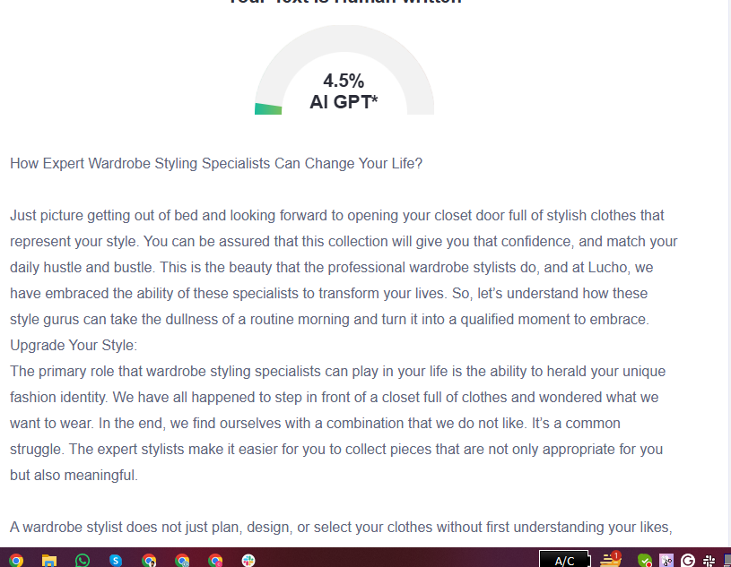

GMB
Imagine waking up excited to open your closet, filled with clothes that perfectly represent your style and boost your confidence. At Lucho, our expert wardrobe styling specialists transform this dream into reality! Our stylists move beyond choosing outfits because they understand personal tastes and needs to create clothing collections that showcase your unique personality. Our team helps you identify the dressing style that suits your personal taste best, which includes classic elegance, urban casual fashion, and sophisticated high-end apparel. A suitable wardrobe possesses two essential powers to enhance your appearance while providing the confidence needed to prevail at any event like a professional actor. Our specialists eliminate both valuable morning time and expenses through their work, which selects durable items while showing you methods to optimize your current wardrobe. The wardrobe collections developed by Lucho's experts enable the representation of your desired image in any professional or special occasion, including weddings and parties. Your wardrobe must evolve to match the developments of life. Stylists at our salon help you shift between phases, guiding what items to release while teaching how to adopt modern and suitable fashion choices. At Lucho, we believe your wardrobe isn't just clothes- it's an expression of who you are and who you aspire to become. Discover how our wardrobe styling specialists can transform your life today!

